ISSACK WAITHAKA
cs-sa07-24085

Forensics – Analyse the PCAP
The first thing was to download the Task files
Questions
1.
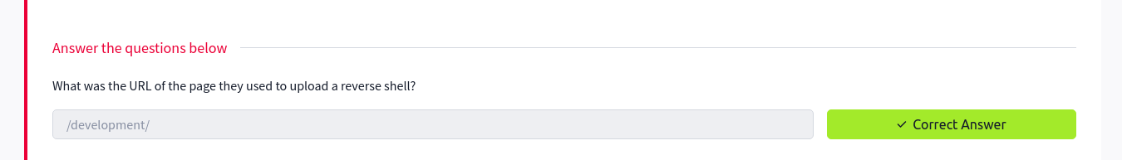
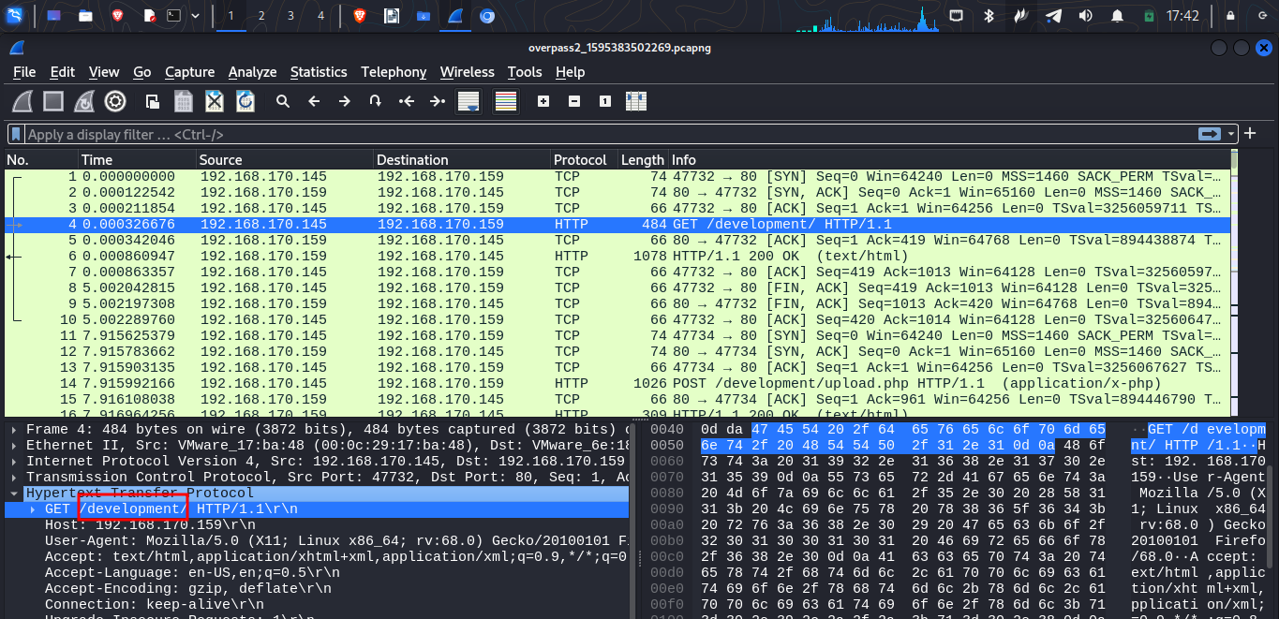
2.

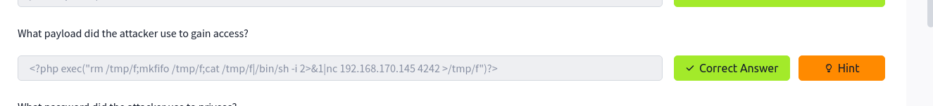

I copied the payload in printable format
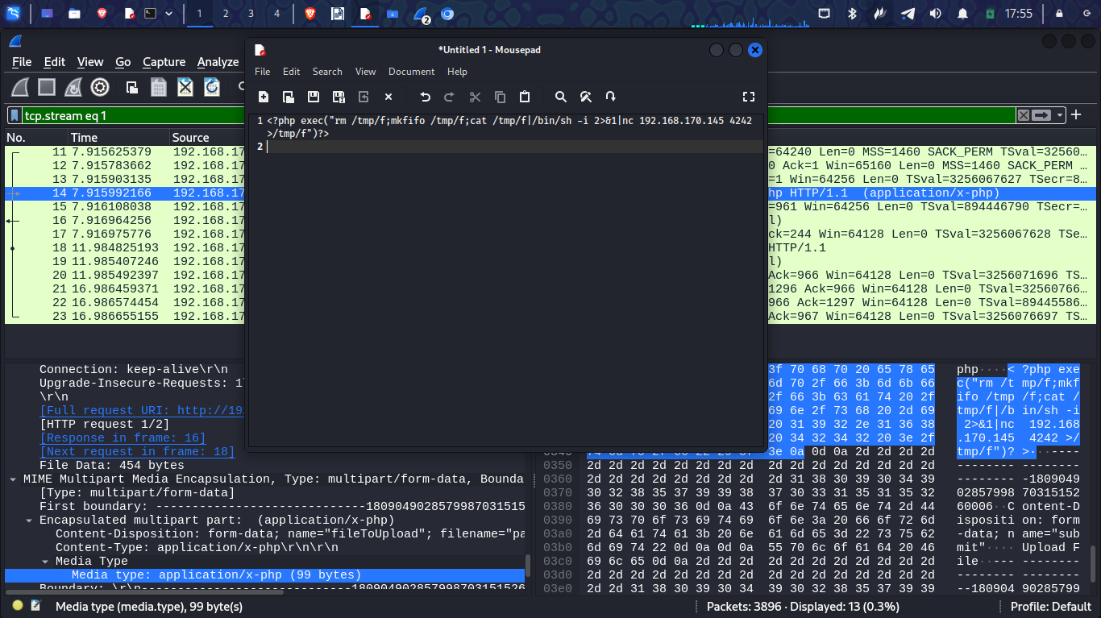

3.
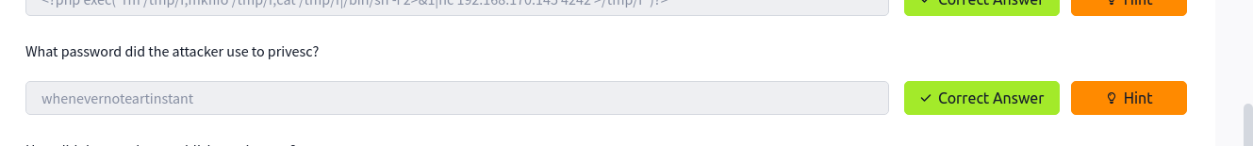
- In the payload it is noticeable that the attacker used netcat to listen on port 4242
- I searched for the port in wireshark the followed the tcp stream and got the password
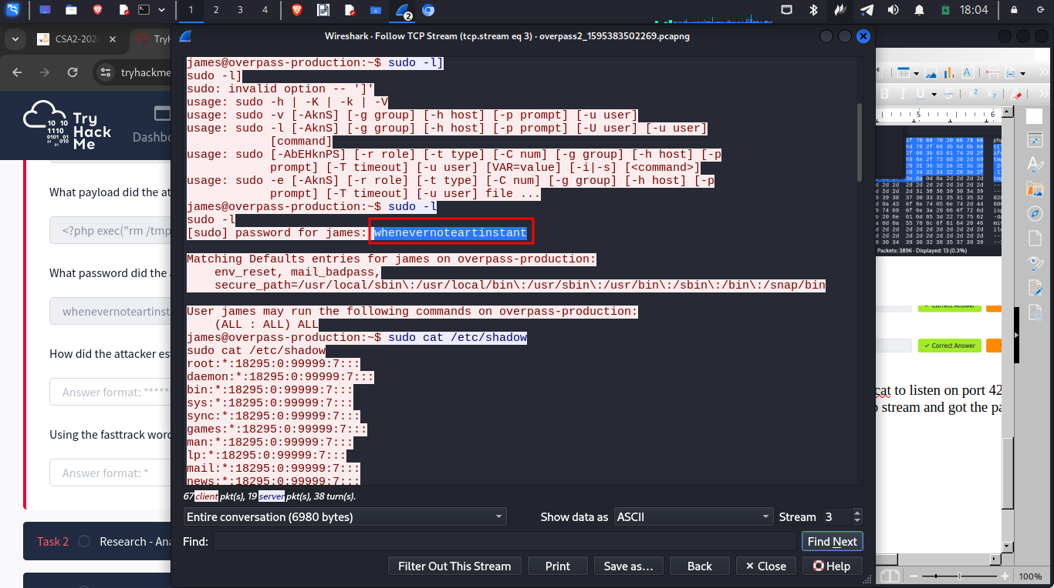

4.
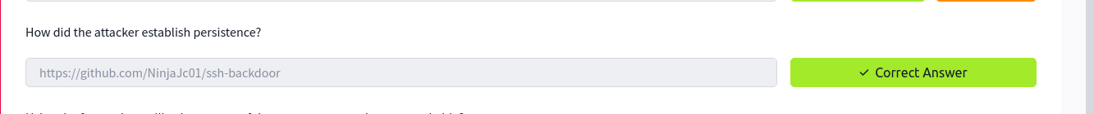
Through this ssh backdoor
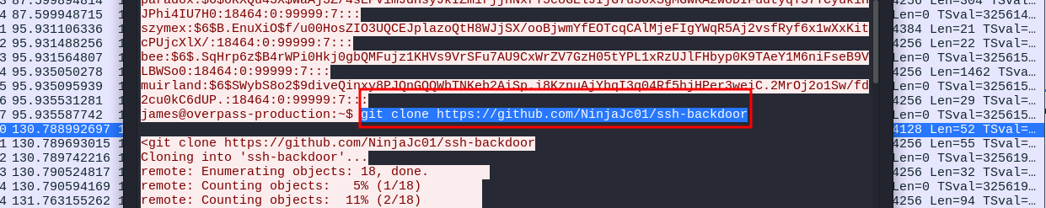

5.
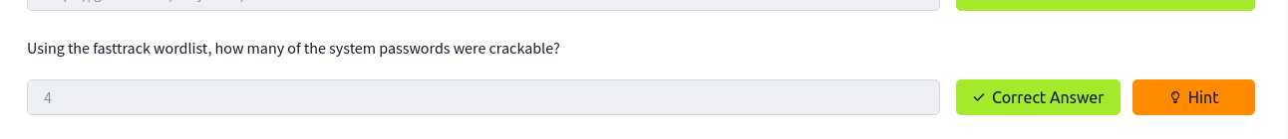
- Fow this I took the hash that is found in the tcp stream, copied it into a file and tried to crack it using john.
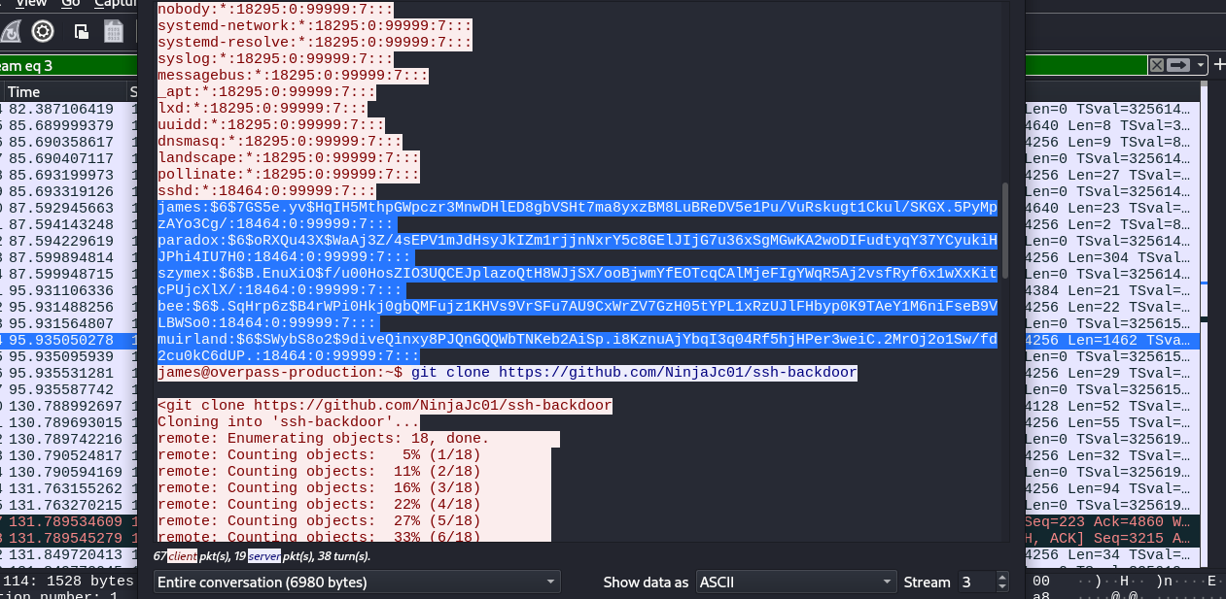
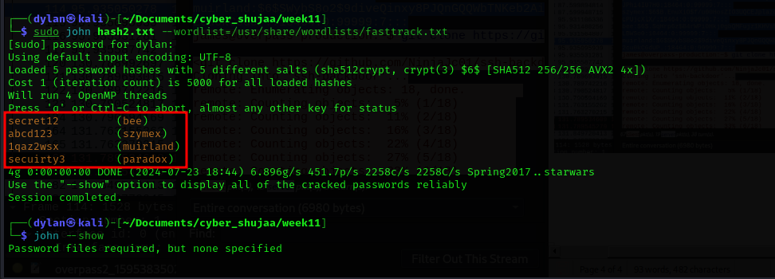

Research – Analyse the code

1.
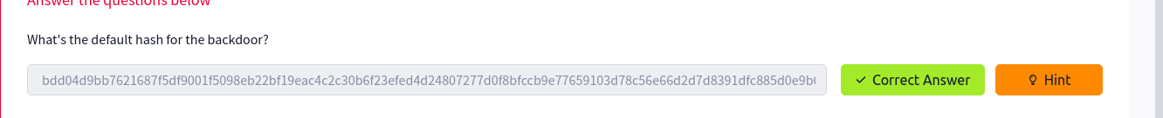
For this I went to github where the ssh-backdoor was. I navigated to the main.go directory and found the hash
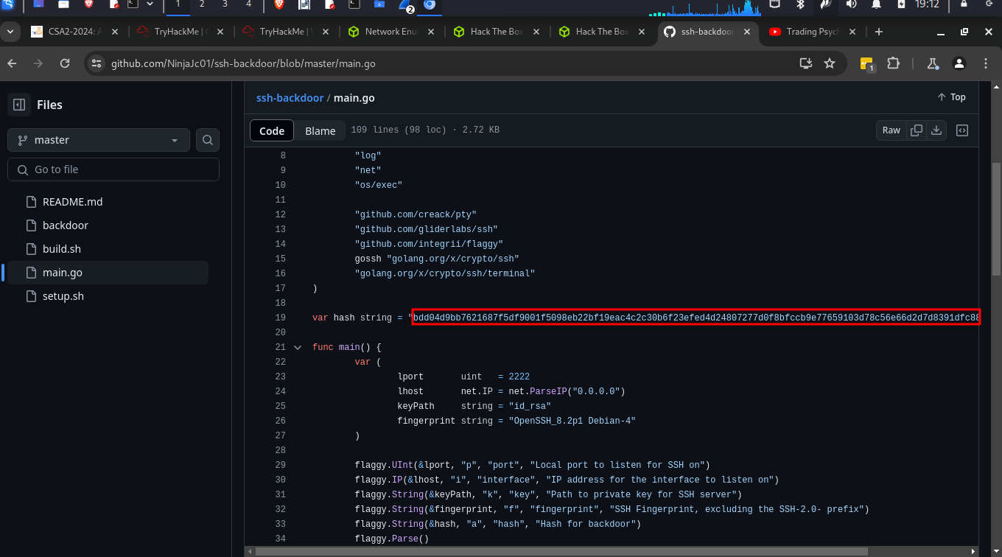

2.

This is the hash
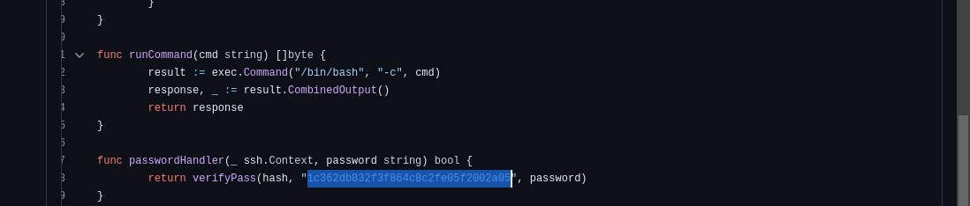
3.

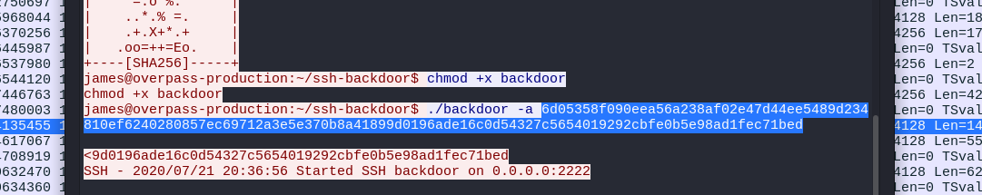

4.

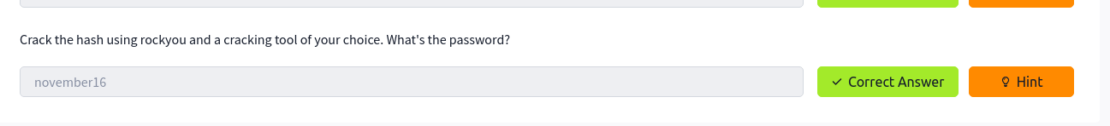
We notice the hashing algorithm being used
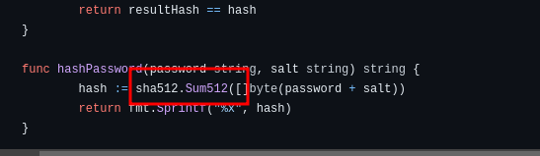
So I used this #

I started hash cat
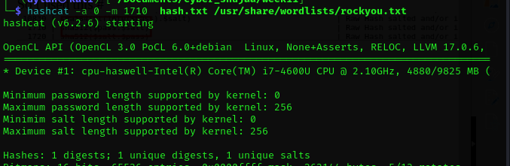
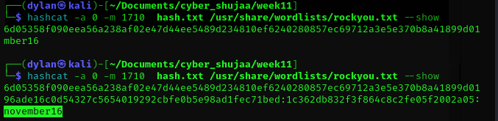

Attack -Get back in!
1.
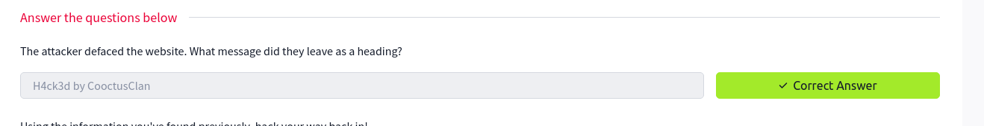
For this I had to start the machine and navigate to the website where I found the message left by the hacker

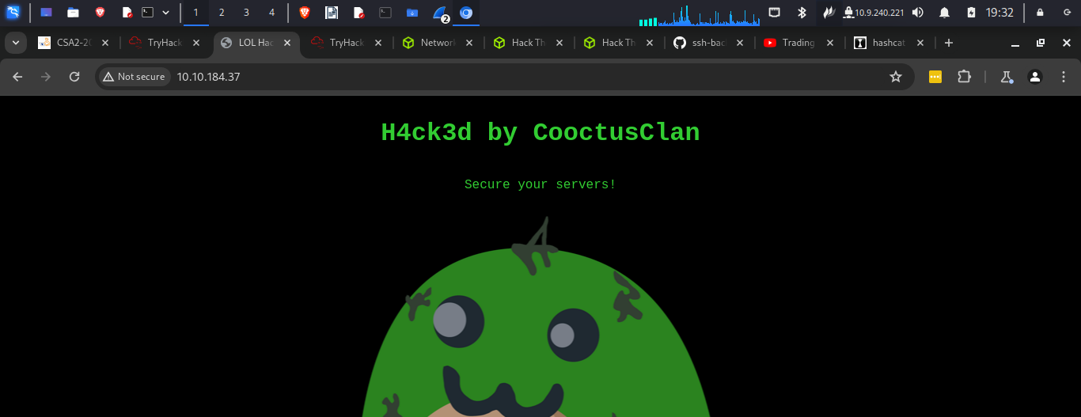

2.
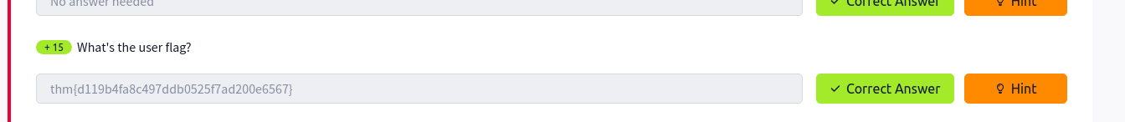
For this I had to check the open ports using nmap. I noticed port 2222 was open. I decided to use it to login through ssh-backdoor
I got this error and googled it got this suggestion
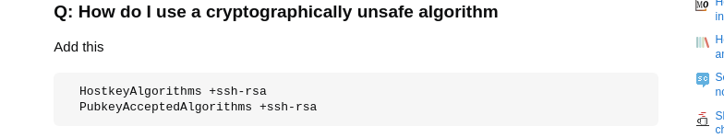
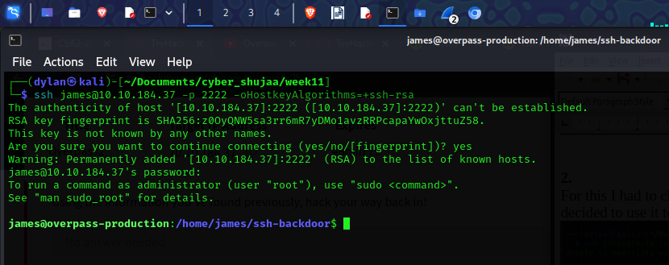
I was able to log in using the password I got earlier

I got the flag
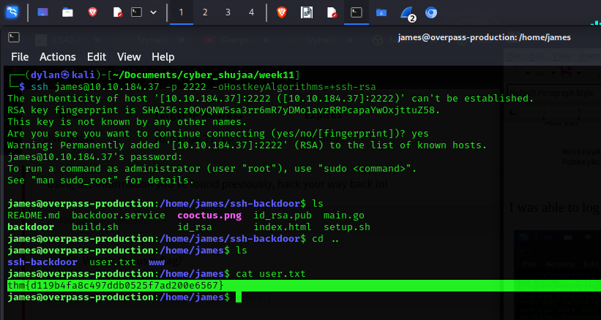

3.
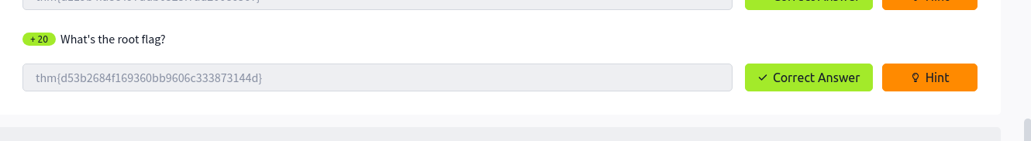
I listed everything and noticed this suspicious bash file
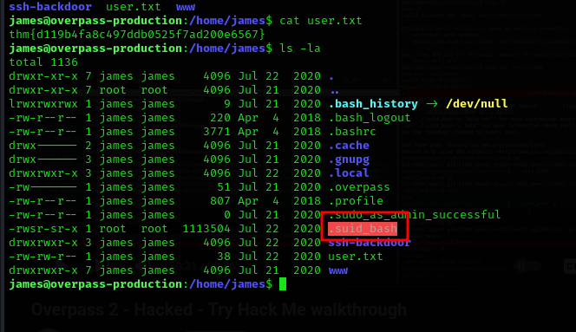
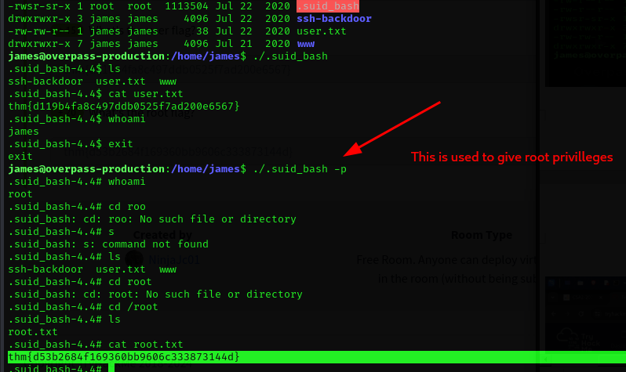

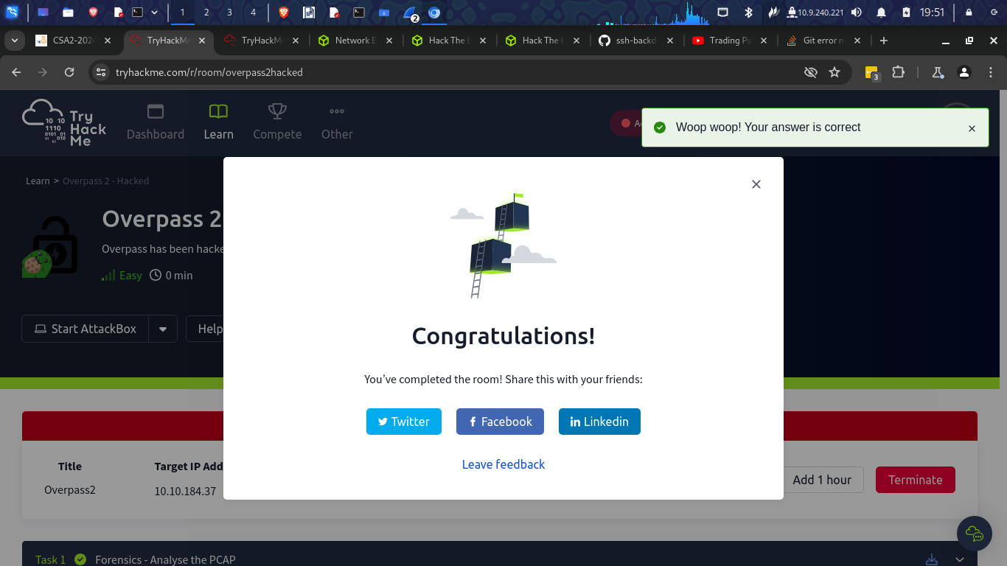

Conclusion
In this module I have learnt something about forensics. I have learnt how to investigate a pap file which is a wireshark file. It was fun to analyses and find the backdoor used for the attack. I have also learnt about decrypting hashes which is something very crucial when it comes to cyber security.

